**Task 2**

1. **Creating The Repository:**

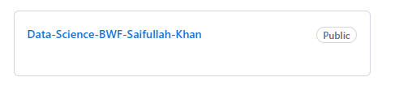

1. **Uploading The Tasks In The Repository By Creating Sub-folders in it:**

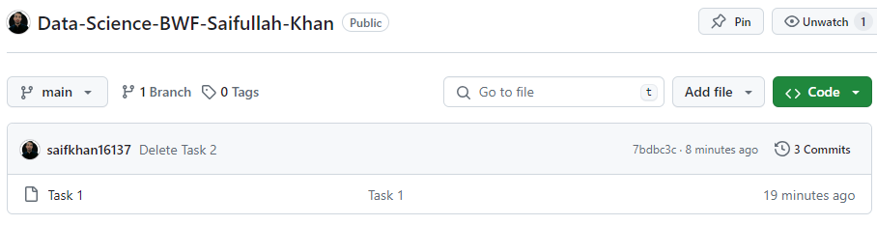

1. **Installing Git on Windows:**

